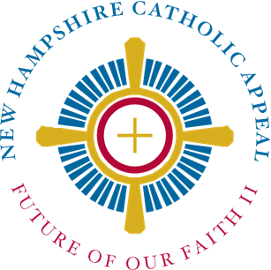

New Hampshire Catholic Appeal: Future of our Faith II
Social Media Toolkit
2024

To use:
- Open your parish's social media account (Facebook, Instagram, X, etc.).
- Copy and paste the text (and save the image and upload it, where applicable) below into the post and share.
- There are two posts per week; use one or both, spaced a few days apart. Some have images which appear to the left or above the post text.
- Highlighted text indicates a name or parish name needs to be inserted.

Posts for Week Leading Up to Announcement Weekend
(Track 1: Week of April 8; Track 2: Week of April 15)
1. This weekend we’ll be announcing the beginning of the 2024 New Hampshire Catholic Appeal! Last year, our parish raised X dollars for our shared ministries of the Church in NH. Our parishioners are wonderfully generous and more information on this year’s NHCA is coming soon!
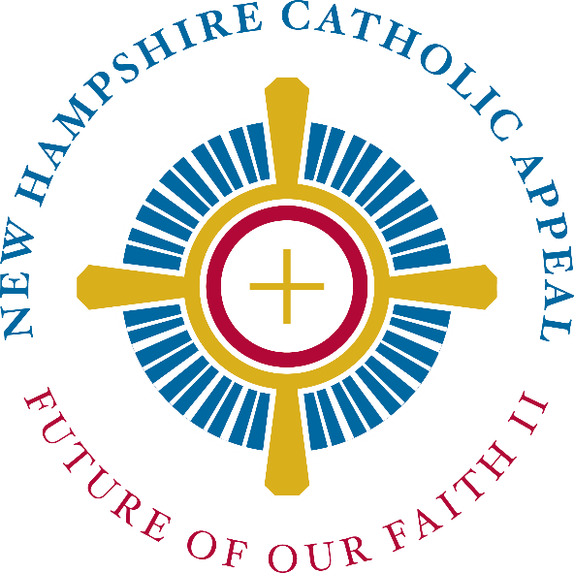
2. This year’s New Hampshire Catholic Appeal is coming up in a few weeks; we hope you’ll help us meet our parish goal! More information will be announced this weekend.

Posts for Week Leading Up to Kick-Off Weekend
(Track 1: Week of April 15; Track 2: Week of April 22)
- This weekend, we kick off our parish’s campaign for the New Hampshire Catholic Appeal! The NHCA strengthens our ministries that support our entire Church in New Hampshire. You may have already received your own NHCA letter from Bishop Peter Libasci. Like last year, we’ll learn more about the ministries supported at Mass next weekend and all are encouraged to learn more about the incredible programs and services your donation to the NHCA supports at www.catholicnh.org/nhca

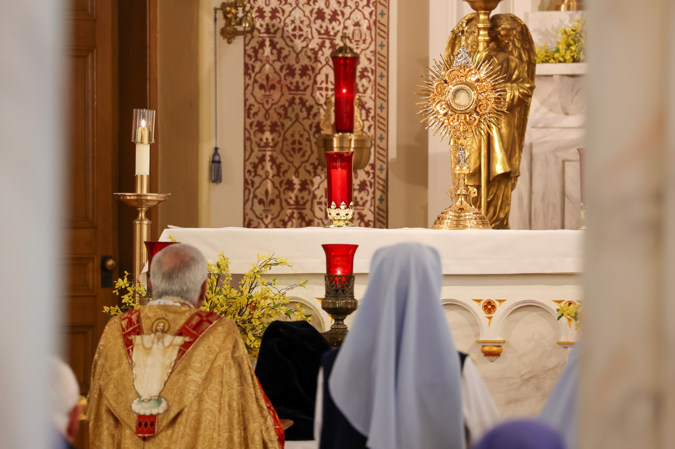2. This weekend, we kick off the New Hampshire Catholic Appeal for 2024. Many of the ministries that we may benefit from in our parish, including Catholic Charities Community Services, Catholic formation, and Catholic education, are funded by the New Hampshire Catholic Appeal. Learn more and donate here: www.catholicnh.org/nhca

Posts for Weeks Leading Up to Appeal Weekend
(Track 1: Week of April 22; Track 2: Week of April 29)
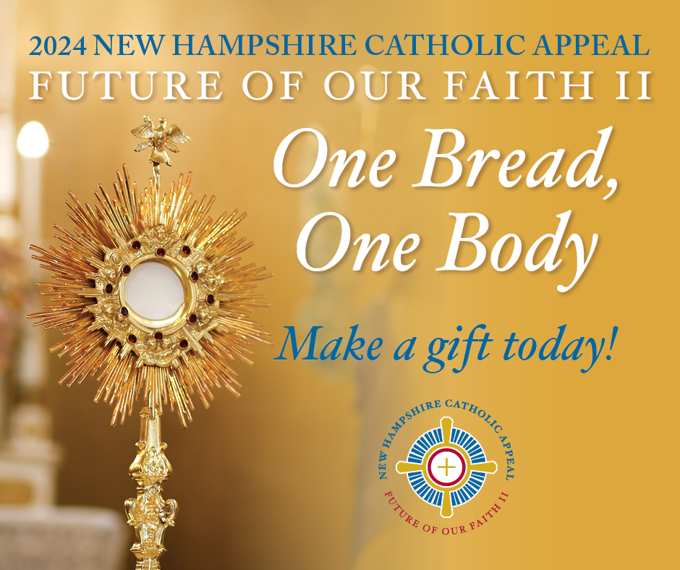
- This weekend we will hear more about the New Hampshire Catholic Appeal during Mass and will have an opportunity to give to this campaign that will help many ministries to keep our faith alive well into the future. You can donate either by returning the envelope you received at your home, completing an envelope in pew at Mass this weekend, or online at www.catholicnh.org/nhca. Help us reach our parish goal this year and give today!
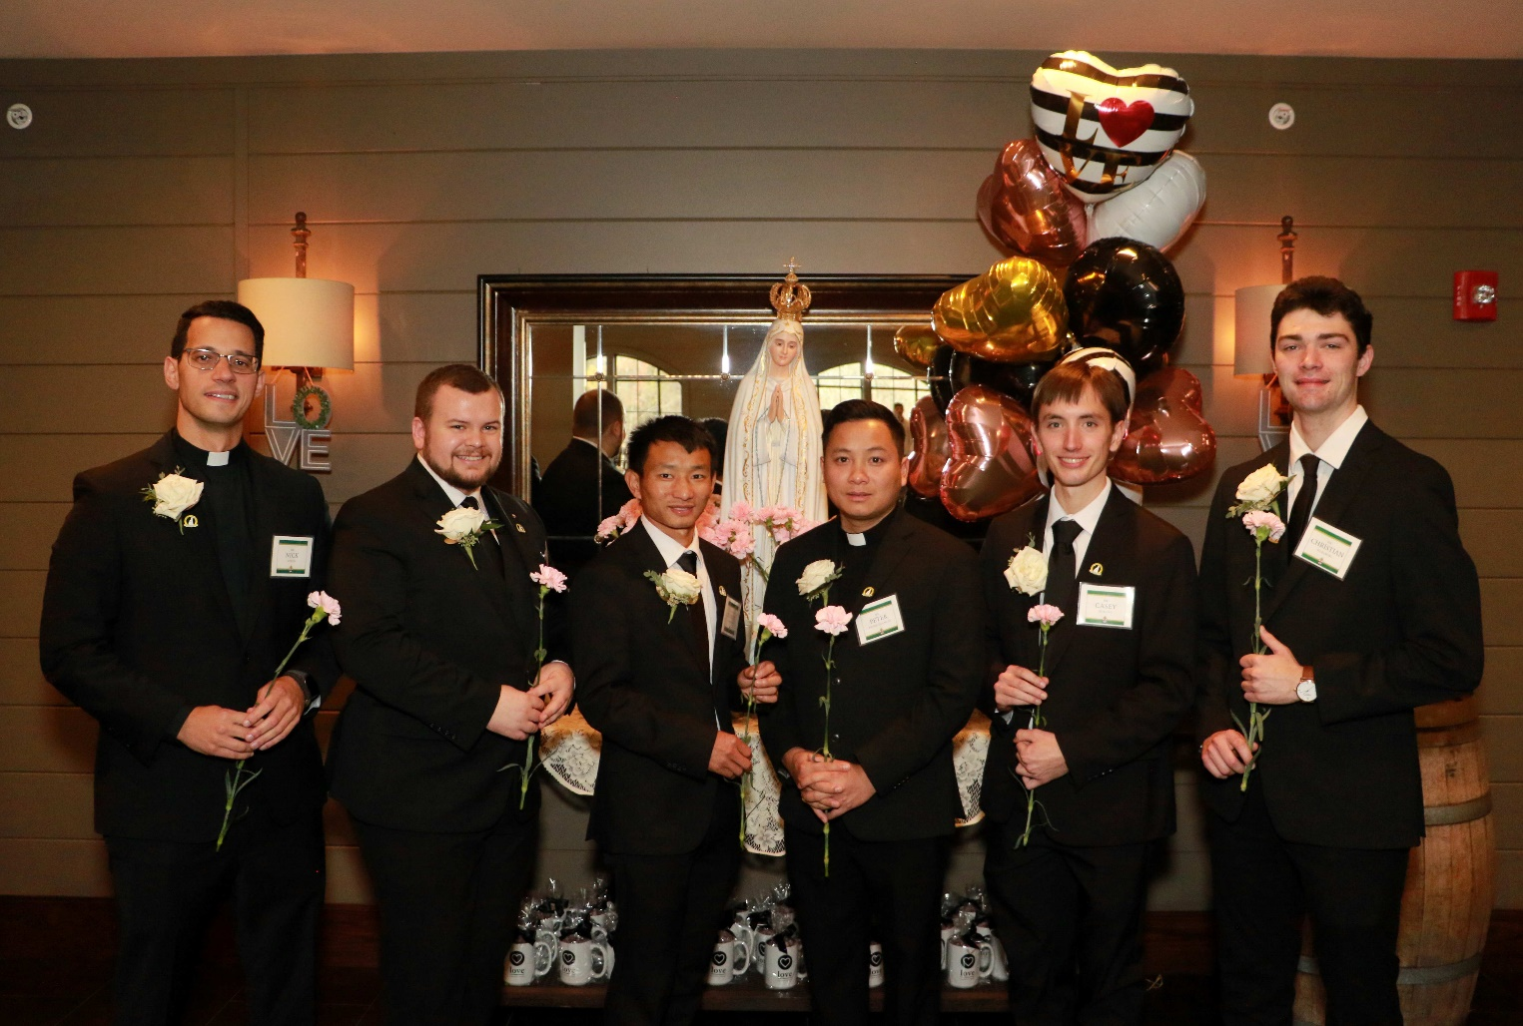2. The New Hampshire Catholic Appeal: Future of our Faith II benefits all our shared ministries, including providing education and formation for our seminarians, the future priests of our Diocese. With your gift to the NHCA, we can continue to provide this essential foundation for their vocation: www.catholicnh.org/nhca

Posts in the Week Following Appeal Weekend
(Track 1: Week of April 29; Track 2: Week of May 6)

- As we heard at Mass this past weekend, a gift to the New Hampshire Catholic Appeal: Future of Our Faith II, will enable the Catholic Church in New Hampshire to meet the increasing needs of parishes, Catholic schools, retired clergy, seminarians and much more. Make a gift today at www.catholicnh.org/NHCA

- Thank you to all who participated in this weekend’s Appeal for our New Hampshire Church! We are hopeful that our parish will meet our goal and help to provide resources for our seminarians, retired priests, Catholic education, evangelization, parishes in need, Catholic formation, Catholic Charities Community Services, cemeteries, and multicultural ministry. If you missed the NHCA this past weekend, you can still donate online (www.catholicnh.org/nhca) or mail in your envelope that you received at home.

